
SOUTHWESTERN STATE COLLEGE
TRIVHUVAN UNIVERSITY
FACULTY OF HUMANITIES AND SOCIAL SCIENCE
PROJECT REPORT
ON
PHISHING LINK DETECTION SYSTEM
Submitted to
Department of Computer of Application
SWSC- Bashundhara, Kathmandu
In partial fulfillment of the requirements for the Bachelor’s in Computer Application

Submitted by
Name: Rojina Ghimire
TU Reg. NO: 6-2-530-26-2020
Under the supervision of
Kiran Ghimire



Tribhuvan University
Faculty of Humanities and Social Science
Southwestern State College

SUPERVISER’S RECOMMENDATION

I hereby recommend that this project report prepared by Rojina Ghimire (6-2-530-26-2020) under the supervision of Mr. Kiran Ghimire entitled “Phishing Link Detection System” in partial fulfillment of the requirements for the degree of Bachelor of Computer Application be processed for the evaluation.

…………………………
Kiran Ghimire
Supervisor
Head of Department of BCA
Southwestern State College
Basundhara, Kathmandu

Tribhuvan University
Faculty of Humanities and Social Science
Southwestern State College

LETTER OF APPROVAL

This is to certify that this project is prepared by Rojina Ghimire (6-2-530-26-2020) entitled “Phishing Link Detection System” in partial fulfillment of the requirements for the degree of Bachelor in Computer Application has been evaluated. In our opinion it is satisfactory in the scope and quality as a project for the required degree.

Kiran Ghimire Kapil Neupane
Project Supervisor Internal Supervisor
BCA Department SWSC

Bikash Parajuli External Examiner
Internal Supervisor Tribhuvan University

ACKNOWLEDGEMENT
This is an attempt to present the project entitled “Phishing Link Detection System” prepared for partial fulfillment of the requirement for the Degree of Bachelor in computer application (BCA) is an outcome of continuous and immeasurable cooperation and support of several hands. I express my sincere honor and special sense of gratitude to my academic supervision Mr. Kiran Ghimire. I would also like to thank all lecturer and friends for their generous guidance, thoughtful encouragement and brilliant insight throughout this work.

With Respect,
Rojina Ghimire
TU Reg: 6-2-530-26-2020

ABSTRACT
Phishing websites are a pervasive threat, often used by cybercriminals to deceive users into disclosing sensitive information by mimicking legitimate sites. This project presents phishing detection system designed to protect users from falling victim to these attacks. Leveraging a Long Short-Term Memory (LSTM) based machine learning model, the system identifies characteristics unique to phishing websites—such as specific URL patterns, domain properties, and site content features. Built with a FastAPI backend and a simple HTML, CSS, and JavaScript frontend, this detection system aims to provide real-time alerts, warning users before they engage with potentially malicious sites. Trained on a publicly available dataset, the model is designed for continuous improvement, adapting to new phishing techniques as they emerge, ensuring robust and up-to-date protection against evolving cyber threats.

Keywords: LSTM, FastAPI, Javascript, machine learning, feature extraction, phishing detection, etc.

TABLE OF CONTENTS
SUPERVISER’S RECOMMENDATION ii
LETTER OF APPROVAL iii
ACKNOWLEDGEMENT iv
ABSTRACT v
TABLE OF CONTENTS vi
LIST OF FIGURES viii
LIST OF TABLES ix
LIST OF ABBREVIRATIONS x
CHAPTER 1: INTRODUCTION 11
1.1 Introduction 11
1.2 Problem Statement 11
1.3 Objectives 12
1.4 Scope and Limitation 12
1.5 Deployment Methodology 12
1.6 Report Organization 14
CHAPTER 2: BACKGROUND STUDY AND LITERATURE REVIEW 15
2.1 Background Study 15
2.1.1 Description of Fundamental Theories 15
3.1.2 General Concept and Terminologies 16
2.2 Literature Review 17
CHAPTER 3: SYSTEM ANALYSIS AND DESIGN 18
3.1 System Analysis 18
3.1.1 Requirement Analysis 18
3.2 Feasibility Analysis 19
3.3 Object Modelling using Class and Object diagram 20
3.3.1 Dynamic Modelling using State and Sequence diagram 21
3.3.2 Process Modelling using Activity Diagram 23
3.3.3 System Design 25
3.3.4 Algorithm Details 27
CHAPTER 4: IMPLEMENTATION AND TESTING 1
4.1 Implementation 1
4.1.1 Tools Used 1
4.1.2 Implementation Details of Modules 2
4.2 Testing 5
4.2.1 Test Cases for Unit Testing 6
4.2.2 Test Cases for System Testing 7
4.3 Result Analysis 8
CHAPTER 5: CONCLUSION AND EXPECTED/LEARNING OUTCOME 10
5.1 Conclusion 10
5.2 Future Recommendation 10
REFERENCES 11
APPENDIX 12

LIST OF FIGURES
Figure 1: V Model 13
Figure 2: Use-case diagram of phishing link detection system 18
Figure 3: Gantt chart of Phishing Link Detection System 20
Figure 4: Class Diagram of Phishing Link Detection System 20
Figure 5: State diagram of Phishing Link Detection System 21
Figure 6: Sequence Diagram of Phishing Link Detection System 22
Figure 7: Activity Diagram of Phishing Link Detection System 23
Figure 8: Refinement of Class and Object Diagram of 25
Figure 9: Deployment Diagram of Phishing Link Detection System 26
Figure 10: LSTM Model Result analysis of phishing Link Detection System 38
Figure 11: Bi LSTM Model Result analysis of phishing Link Detection System 39
Figure 12: CNN-LSTM Model Result analysis of phishing Link Detection System 40
Figure 13: Landing Page of Phishing Link Detection System 44
Figure 14: Detection of Phishing and Non-phishing on 45

LIST OF TABLES
Table 1: Unit Testing of Phishing Link Detection System 6
Table 2: System Testing of Phishing Link Detection System 7

LIST OF ABBREVIRATIONS
AI: Artificial Intelligence
API: Application Programming Interface
BiLSTM: Bidirectional Long Short-Term Memory
CNN: Convolutional Neural Network
CSS: Cascading Style Sheets
HDF5: Hierarchical Data Format Version 5
HTML: Hyper Text Markup Language
JS: JavaScript
LSTM: Long Short-Term Memory
MI: Machine Learning
REST: Representational State Transfer
RNN: Recurrent Neural Network
UI: User Interface
V-Model: Verification and Validation Model
XML: Extensible Markup Language

CHAPTER 1: INTRODUCTION

Introduction
Phishing websites have become a primary method for cybercriminals to steal sensitive information from unsuspecting users. These fraudulent sites are designed to closely mimic the appearance and functionality of legitimate websites, often convincing users to enter personal details, login credentials, or financial information. As a result, phishing attacks can lead to severe consequences, including identity theft, financial losses, and data breaches.
This project seeks to address this critical issue by developing a phishing site detection system that helps safeguard users from falling victim to these deceptive attacks. The primary objective is to build a machine learning model that can accurately detect phishing websites and alert users before they inadvertently provide sensitive information to malicious actors.
To achieve this, the project will utilize publicly available datasets containing features related to phishing websites, such as URL patterns, domain information, page content, and other technical aspects that distinguish phishing sites from legitimate ones. By training a machine learning model on this dataset, the system will learn to identify patterns and anomalies that are indicative of phishing attempts.
Once trained, the system will provide warnings to users attempting to visit phishing sites, offering an essential layer of protection against one of the most prevalent forms of cyber threats.

Problem Statement
Phishing remains one of the most prominent and persistent cybersecurity threats that continues to target individuals and organizations globally. This malicious activity involves fraudulent attempts to acquire sensitive information, such as usernames, passwords, and financial details, by disguising as trustworthy entities. Phishing attacks can lead to significant financial losses, identity theft, and reputational damage for both individuals and businesses.
Despite ongoing efforts to combat phishing, current cybersecurity measures often prove to be reactive rather than proactive. Traditional defenses, such as email filtering and spam detection, while useful, are increasingly less effective against the ever-evolving tactics used by cybercriminals. Attackers constantly adapt their methods, utilizing sophisticated techniques like social engineering, advanced spoofing, and highly personalized phishing emails that are harder to distinguish from legitimate communications.
As a result, many organizations and individuals remain vulnerable to these increasingly sophisticated attacks. The reactive nature of current cybersecurity strategies, which typically respond to phishing incidents after they occur, leaves critical gaps that attackers can exploit.

1.3 Objectives
The primary objectives of this project are:
- Develop an advanced phishing link detection system using machine learning.
- Enhance online security by real-time identification and blocking of malicious URLs.
- Promote user awareness and education about phishing risks.
- Optimize performance for fast, efficient, and reliable real-time detection.
- Provide a user-friendly interface for easy integration and use of the system.

1.4 Scope and Limitation
This project focuses on developing an end-to-end machine learning application for phishing URL detection, offering a user-friendly interface for submitting URLs and receiving real-time phishing detection results. The system aims to enhance online security by accurately identifying and blocking phishing attempts, thereby protecting users from potential financial losses and identity theft. Additionally, it is designed to integrate with existing cyber security frameworks, such as firewalls and antivirus software, to provide comprehensive protection. The detection system will be continuously updated and refined to adapt to evolving phishing tactics and emerging cyber threats.
However, the system does have certain limitations. It is specifically designed to detect phishing URLs and may not be capable of identifying other forms of cyber threats, such as malware or ransom ware. Furthermore, the system might struggle to accurately detect new or highly sophisticated phishing techniques that are not well-represented in the training data. There is also a potential for false positives, where legitimate URLs are incorrectly flagged as phishing attempts, and false negatives, where phishing URLs go undetected. These limitations can affect the overall accuracy and reliability of the system, requiring ongoing refinement to minimize their impact.

1.5 Deployment Methodology
The V-model development methodology can be effectively applied to the creation of a phishing link detection system, ensuring a structured and rigorous development process. This model emphasizes a sequential, validation-driven approach where each development phase is paired with a corresponding testing phase, enabling early identification and resolution of potential issues. The system's requirements, including the need for accurate phishing detection, scalability, and user-friendliness, are gathered and analyzed in the initial stages. These requirements directly influence the design of both the LSTM-based detection algorithm and the architecture of the FastAPI backend. Subsequent phases involve the detailed design of components like data preprocessing, model training, API integration, and frontend development using HTML, CSS, and JS. Each phase is validated through rigorous testing, such as unit testing of model components, integration testing of APIs, and system testing to evaluate end-to-end functionality. This structured approach ensures that the detection system meets performance, security, and usability criteria before deployment, while fostering a clear alignment between development goals and quality assurance activities.
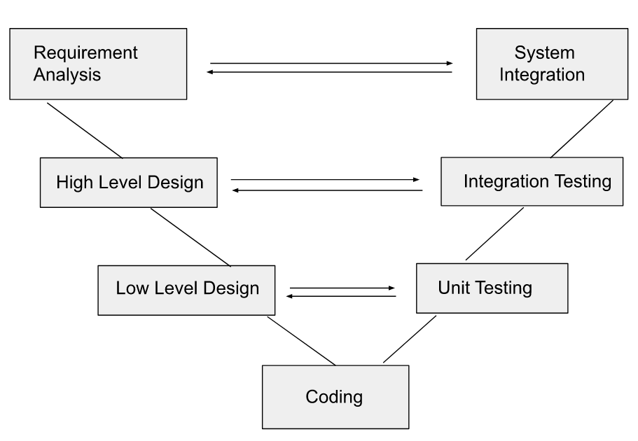

Figure 1: V Model

1.6 Report Organization
Chapter 1
This chapter introduces the core problem of phishing attacks and their implications for individuals and organizations. It outlines the project's objective to develop a phishing link detection system leveraging machine learning techniques. The chapter also presents the problem statement, objectives, and scope, providing a comprehensive overview of the project's goals, limitations, and the chosen development methodology.
Chapter 2
This chapter explores the foundational concepts related to the project, such as deep learning and Long Short-Term Memory (LSTM) networks. It provides a literature review of existing phishing detection solutions, analyzing their methodologies and technologies, including comparisons between traditional machine learning and modern deep learning techniques.
Chapter 3
In this chapter, the system's architecture and design are described in detail. It includes system requirements analysis (functional and non-functional), feasibility analysis (technical, operational, and economic), and various diagrams such as use-case, class, sequence, and activity diagrams. These provide a clear understanding of the system's structure and workflow.
Chapter 4
This chapter discusses the implementation details of the phishing link detection system, including the tools and technologies used, the system's components, and the methodologies applied to develop and deploy the system. It also explains the testing process, providing test cases and results for unit and system testing to ensure the system functions as intended.
Chapter 5
The final chapter summarizes the project's achievements and limitations. It also provides recommendations for future improvements and enhancements to make the system more robust, accurate, and adaptable to emerging phishing techniques. This section ensures the project's potential for continued development and optimization.

CHAPTER 2: BACKGROUND STUDY AND LITERATURE REVIEW

2.1 Background Study
This section consists of background study on terminologies related to our project and a review of existing solutions.

2.1.1 Description of Fundamental Theories
Phishing link detection is based on several key computational and security theories that guide how systems identify malicious URLs. The fundamental theories include:
1. Pattern Recognition Theory
This theory enables the system to identify patterns or anomalies in URLs that are common in phishing attempts. Features like domain name structure, use of special characters, URL length, and presence of IP addresses are extracted and analyzed to detect suspicious patterns.
2. Machine Learning Theory
Machine learning provides the foundation for training models to distinguish between phishing and legitimate links. By learning from large datasets of labeled URLs, algorithms such as LSTM, BiLSTM, and CNN build classification boundaries based on input features. Over time, the model adapts to detect newly emerging threats.
3. Natural Language Processing (NLP) Theory
NLP techniques help analyze the structure of URLs as sequences of characters or tokens. Sequence-based models like LSTM and BiLSTM apply NLP concepts to understand context and temporal dependencies in URL text, improving prediction accuracy for sophisticated phishing links.

4. Statistical Learning Theory
This theory underpins the ability of the model to generalize from training data to unseen data. It ensures that the learning algorithm minimizes both bias and variance to avoid overfitting or underfitting, which is critical in phishing detection where new patterns constantly evolve.
5. Information Security Principles
Core principles of cybersecurity, such as confidentiality, integrity, and availability (CIA), guide the goal of phishing detection: to protect users from threats that compromise sensitive data. These principles shape the system's objectives and the evaluation of model effectiveness.

3.1.2 General Concept and Terminologies
1. General Concept
A Phishing Link Detection System is designed to automatically analyze and classify website URLs as either legitimate or phishing. Phishing websites are malicious pages created to mimic trusted ones in order to trick users into revealing sensitive data such as login credentials, credit card numbers, or personal details.
The system leverages machine learning and deep learning models that are trained on large datasets of labeled URLs. These models learn to detect patterns, behaviors, and anomalies in URLs that are often associated with phishing attacks.
2. Key Terminologies
Key terminologies of phishing link detection system are as follows:
- Phishing: A cyberattack that tricks users into revealing personal information through fake websites.
- URL (Uniform Resource Locator): The web address analyzed by the system to check for phishing traits.
- Legitimate URL: A safe and verified web address that is not harmful.
- Phishing URL: A fake or malicious web address meant to mimic a real website.
- Feature Extraction: The process of pulling out specific traits from a URL (like length, domain and symbols) for analysis.
- Classification Model: The machine learning/deep learning algorithm that classifies the URL as phishing or not.
- LSTM (Long Short-Term Memory): A deep learning model used to analyze sequences like URL text patterns.
- BiLSTM (Bidirectional LSTM): An advanced version of LSTM that reads input in both directions for better accuracy.
- CNN (Convolutional Neural Network): A model that can learn spatial patterns, adapted here for URL structure recognition.
- Training Data: Labeled examples of phishing and legitimate URLs used to train the detection system.
- Prediction Score: The percentage output from the model showing how likely a URL is phishing.
- False Positive: A legitimate URL that is incorrectly marked as phishing.
- False Negative: A phishing URL that is incorrectly marked as legitimate.

2.2 Literature Review
Existing phishing detection systems have explored various approaches to combat the growing threat of fraudulent websites. PhishShield (Rou, 2015) employs a Random Forest algorithm to detect phishing URLs, extracting a range of features from the URLs such as domain age, URL length, and presence of special characters. By training the Random Forest model on these URL-based characteristics, the system is able to learn patterns that distinguish phishing URLs from legitimate ones. On the other hand, EasyDMARC (easydmarc., n.d.) utilizes a Long Short-Term Memory (LSTM) neural network to analyze the sequential patterns present in URLs. Leveraging the LSTM's ability to capture long-term dependencies in sequential data, the system can identify subtle anomalies and suspicious characteristics indicative of phishing attempts. These two contrasting approaches, one using traditional machine learning and the other employing deep learning techniques, demonstrate the diverse methodologies being explored to enhance the detection and prevention of phishing websites.

CHAPTER 3: SYSTEM ANALYSIS AND DESIGN

3.1 System Analysis
The project will be explained using dataflow diagrams, flowcharts, use-case diagrams, connection and entity diagrams, and so on.

3.1.1 Requirement Analysis
The Phishing Link detection System requirement analysis entails identifying and defining the features, functionalities, and requirements necessary for the website to run effectively and efficiently.

i. Functional Requirements
- The system shall allow users to enter url for analysis.
- The system shall analyze url that is entered by user in real time to detect phishing links. .
- The system shall view result and warn the users about the sites.

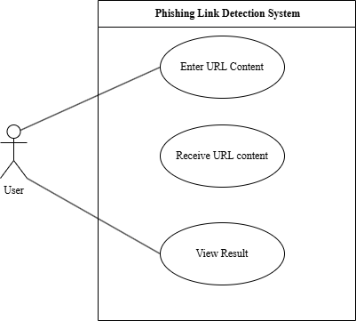
Figure 2: Use-case diagram of phishing link detection system

ii. Non Functional Requirements
- The system must have an intuitive UI.
- The system must be secured.
- The system must have a good response

3.2 Feasibility Analysis

i. Technical
Our project designs the UI using HTML, CSS and JavaScript for smooth user experience. We have a backend on FastAPI that loads the model and exposes prediction endpoint which returns if the URL is phishing or not along with the model’s prediction percentage. We use hardware, software with the latest version and existing technologies.

ii. Operational
The operation feasibility determines if a system can be successfully deployed and operated reliably. Because the suggested system is web-based, it is platform independent. It is simple to access through a variety of platforms. The simple user interface will be simple to grasp and use.

iii. Economic
Most materials are freely available, and most software can be utilized complies with fair use laws and uses open-source technologies. Thus, developing the project had no associated costs. The proposed system is therefore economically feasible. However, as we are building a machine learning model, we are restricted by hardware limitations on how much training we can do. We can use dedicated cloud solutions for training our model but it would add costs.

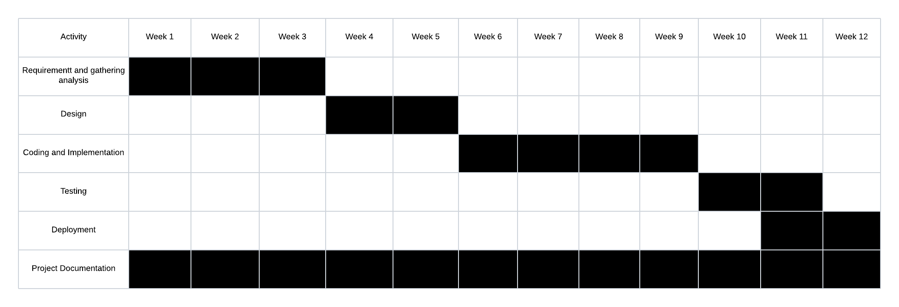
iv. Schedule
Figure 3: Gantt chart of Phishing Link Detection System

3.3 Object Modelling using Class and Object diagram

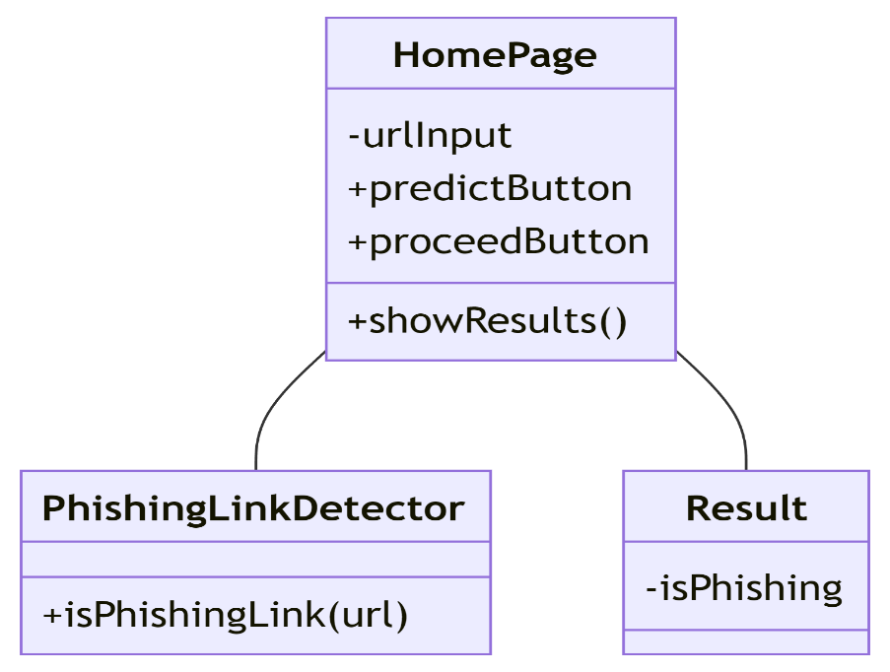

Figure 4: Class Diagram of Phishing Link Detection System
In figure 4, it shows structure of a phishing link detection system. The HomePage class serves as the user interface, allowing users to input a URL (urlInput) and interact using buttons like predictButton to initiate prediction and proceedButton to continue after results are displayed. It has a method showResults() to display outcomes. The PhishingLinkDetector class provides the core functionality through the isPhishingLink(url) method, which determines if a given URL is a phishing link. The Result class encapsulates the outcome with an isPhishing attribute, indicating whether the URL is safe or malicious. The relationship reflects data flow from user input to detection and result display.

3.3.1 Dynamic Modelling using State and Sequence diagram

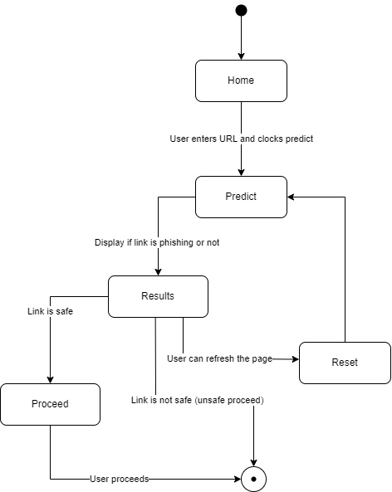

Figure 5: State diagram of Phishing Link Detection System
In figure 5, it shows user flow for a phishing link detection system. The user begins on the “Home” page. They then input a URL into the designated box on the “Enter URL” screen. Clicking the "Predict" button initiates the analysis process. The system then displays the results, indicating whether the URL is deemed a phishing link or not on the “Show Results” screen. Only after viewing these results can the user proceed by clicking the “Proceed” button, moving them to the final stage of the process. If “Reset” is pressed the state gets reset to “Predict” resetting the flow.
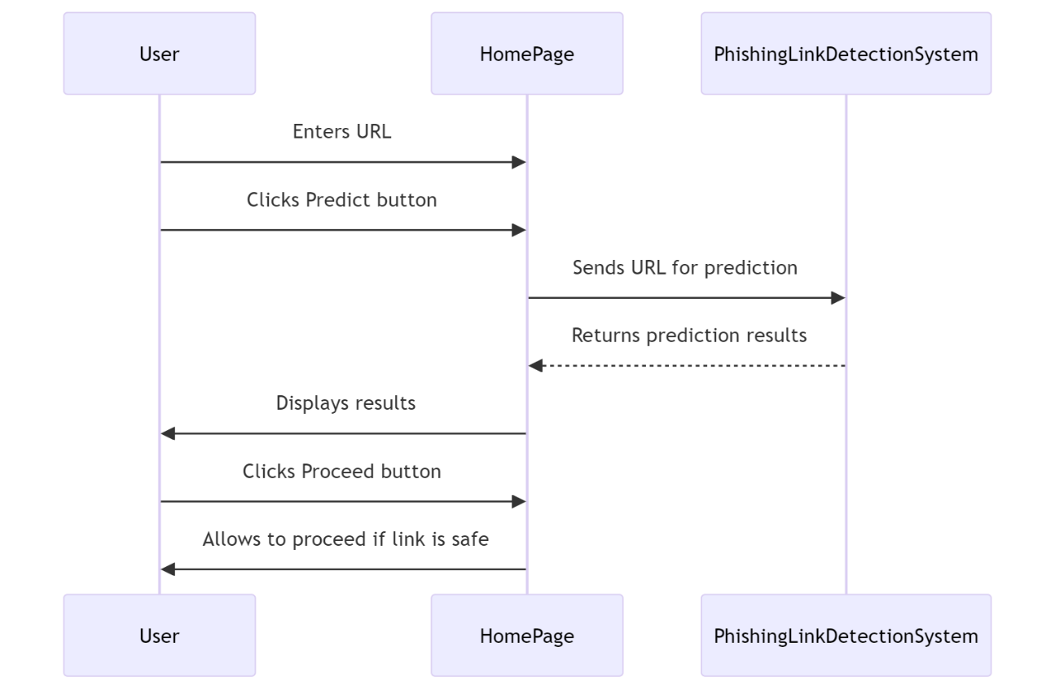

Figure 6: Sequence Diagram of Phishing Link Detection System
In figure 4, it shows the interaction flow in a phishing link detection system. A user enters a URL on the homepage and clicks the “Predict” button. The homepage sends the URL to the phishing detection system, which processes it and returns prediction results. The results are displayed to the user. If the link is safe, the user can proceed by clicking the “Proceed” button, and the system allows further actions. This ensures that unsafe links are identified and blocked before the user interacts with them.

3.3.2 Process Modelling using Activity Diagram

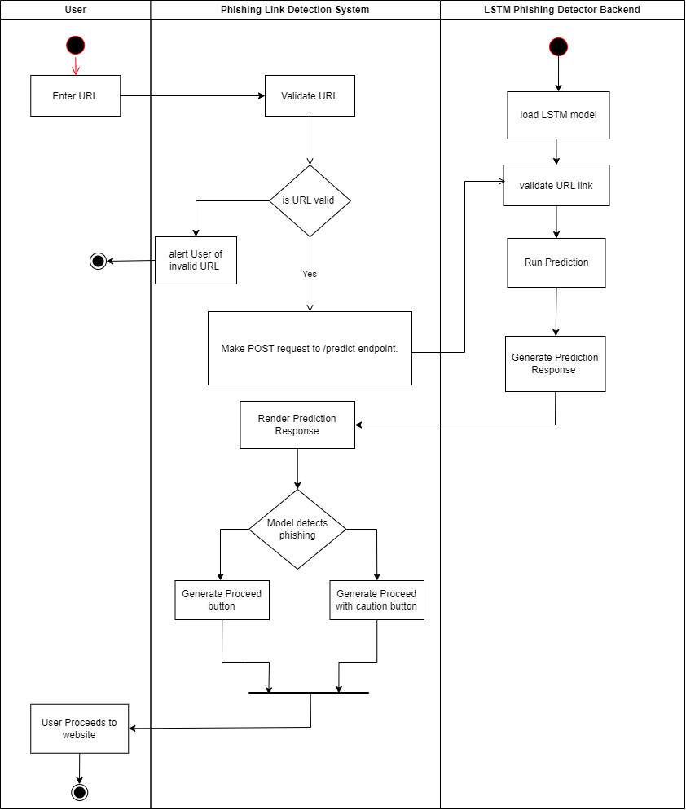
Figure 7: Activity Diagram of Phishing Link Detection System

This activity diagram represents the process flow of a phishing link detection system that interacts with users and an LSTM-based phishing detection backend. The process begins with the user entering a URL into the system. The phishing link detection system validates the URL to ensure it is formatted correctly. If the URL is invalid, the system alerts the user and terminates the process. If the URL is valid, the system makes a POST request to the /predict endpoint of the LSTM phishing detector backend.
The backend starts by loading the pre-trained LSTM model. It then validates the URL format and runs the phishing detection prediction using the LSTM model. Once the prediction is completed, the backend generates a prediction response, which it sends back to the phishing link detection system.
Upon receiving the prediction response, the phishing detection system evaluates whether the model has flagged the URL as phishing. If the URL is classified as phishing, the system generates a “Proceed with caution” button, warning the user about the potential risk. If the URL is deemed safe, a regular “Proceed” button is generated. The user can then proceed to the website based on their choice, marking the end of the process.
This diagram highlights the interaction between the user, the phishing detection system, and the backend, focusing on validation, prediction, and user decision-making. It ensures a structured approach to detecting and managing potentially harmful URLs.

3.3.3 System Design

3.3.3.1 Refinement of Class and Object diagram

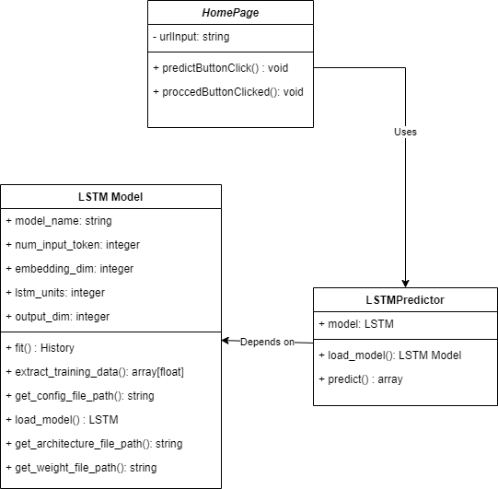
Figure 8: Refinement of Class and Object Diagram of
Phishing Link detection System
The class diagram depicts a system with three interconnected components. The HomePage class represents the user interface, where users input a URL via the urlInput attribute. It provides two key methods: predictButtonClick(), which initiates the prediction process, and proceedButtonClicked(), which performs additional actions after the prediction. The HomePage class interacts with the LSTMPredictor class to handle predictions.
The LSTMPredictor class serves as the intermediate component that manages the machine learning model. It holds a reference to the LSTM model through its model attribute. This class provides methods such as load_model(), which loads the trained LSTM model, and predict(), which performs predictions and returns the results. The LSTMPredictor relies on the LSTM class to implement its functionality.
The LSTM class encapsulates the details of the machine learning model. It includes attributes like model_name (to specify the name of the model), num_input_token (the number of input tokens), embedding_dim (dimension of word embeddings), lstm_units (number of LSTM units), and output_dim (dimension of the output). It provides methods such as fit(), which trains the model and returns a training history, extract_training_data() to extract training data, and methods like get_config_file_path(), get_architecture_file_path(), and get_weight_file_path() to retrieve the file paths for model configuration, architecture, and weights. Additionally, the load_model() method is used to load a trained LSTM model.

3.3.3.2 Deployment Diagram
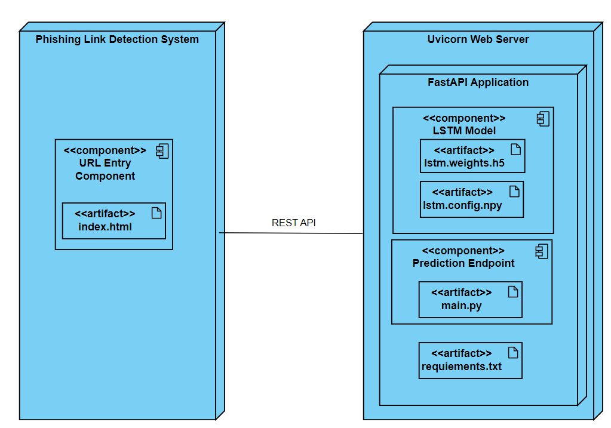
Figure 9: Deployment Diagram of Phishing Link Detection System
This deployment diagram illustrates the architecture of a phishing link detection system and highlights the interaction between the client-side and server-side components.
On the left, the Phishing Link Detection System is represented as a standalone component with a URL Entry Component. This component handles user interactions, such as accepting a URL input for validation and prediction. It is linked to an artifact called index.html, which represents the front-end HTML file that facilitates the user interface.
On the right, the Uvicorn Web Server hosts the server-side application. Within this server, there is a FastAPI Application that manages the backend logic. This application contains two key components:
LSTM Model: This component is responsible for performing phishing detection. It includes two artifacts:
- lstm.weights.h5: The pre-trained model weights stored in an HDF5 file.
- lstm.config.npy: The configuration file for the LSTM model, which might include metadata such as input size, output size, or other parameters.
Prediction Endpoint: This component provides a REST API endpoint for predictions under /predict endpoint. It includes the artifact main.py, which contains the Python code that handles the FastAPI application logic, processes requests, and invokes the LSTM model. Additionally, it has a requirements.txt artifact that lists the dependencies required to run the application, ensuring the server environment is correctly configured.
The interaction between the client and the server is facilitated via a REST API. The front-end component (index.html) sends requests to the server's prediction endpoint, which processes the input, runs the LSTM model, and returns the result. This deployment diagram effectively captures the modular structure, showing the separation of concerns between the user interface, backend API, and the LSTM model, ensuring scalability and maintainability

3.3.4 Algorithm Details

3.3.4.1 Long Short-Term Memory (LSTM)
LSTM, or Long Short-Term Memory, is a type of Recurrent Neural Network (RNN) designed to process sequential data. It is capable of retaining long-term dependencies in sequences, which is important for detecting subtle patterns across the length of a URL. In this system, each URL is treated as a sequence of characters or tokens, and the LSTM model learns to identify suspicious features such as abnormal domain names, uncommon top-level domains (TLDs), or specific keyword arrangements that are typical in phishing attempts.

3.3.4.2 Bidirectional LSTM
BiLSTM extends the capabilities of LSTM by introducing bidirectional processing. This means it analyzes the URL sequence both forward and backward, allowing it to capture context from both ends of the input. This is particularly useful for detecting phishing URLs where malicious indicators may be located at either the beginning or the end of the URL. BiLSTM tends to outperform standard LSTM in accuracy due to its richer contextual understanding.

3.3.4.3 Convolutional Neural Networks (CNNs)
CNN, although traditionally used for image processing, has been adapted in this project to analyze URL text. It uses convolutional filters to detect local patterns within the URL, such as short character sequences or substrings (e.g., “login”, “secure”, “.xyz”, etc.) that are often present in phishing links. CNN models are computationally efficient and excel at identifying localized features, although they may not capture long-range dependencies as effectively as LSTM-based models.
By combining these three models, the system benefits from both local pattern recognition (via CNN) and sequence-based contextual understanding (via LSTM and BiLSTM). This multi-model approach increases the reliability of phishing detection and helps improve prediction accuracy across a wide range of URL types.

CHAPTER 4: IMPLEMENTATION AND TESTING

4.1 Implementation
Implementation refers to the process of translating a concept or plan into a tangible reality by executing the necessary actions and steps. It involves putting the ideas, designs, and strategies into practice to create a functioning product, system, or solution. In the context of Phishing Link Detection System, implementation refers to the actual development and deployment of the system based on the defined requirements and specifications.

4.1.1 Tools Used
- PYTHON
Python is a popular, high-level programming language that is widely utilized in diverse applications like scientific computing, web development, data analysis, artificial intelligence, and more. It supports a wide range of object-oriented programming (OOP) concepts, including encapsulation, inheritance, and polymorphism. Python also boasts a rich collection of third-party frameworks and standard libraries for various applications, making it a popular choice for developers and organizations.
- HTML
HTML, which stands for Hypertext Markup Language, is a markup language that is primarily used to create web pages and web applications.HTML is used to create the simple college website in this project.
- CSS
Cascading Style Sheets (CSS) is a style sheet language that is utilized to describe the presentation of a web document written in HTML or XML. It is used to style the website which is created with HTML in this project.
- Visual Studio Code
This is our code editor where we have written our all of codes. This tool is very user friendly and have lots of extensions which helps for making the coding process more efficient.

- Snipping Tool
This is a pre-installed tool on our Windows Machine which helps to take the screenshots of all required figures, documents and user interfaces.
- Microsoft Word
This tool is used to do all the documentation of our project from the scratch to the very end.
- Microsoft PowerPoint
This tool is used to make the PowerPoint slides to do presentation of our project.
- FastAPI (Backend Framework)
Used for developing the backend RESTful API to handle URL submissions, interact with the machine learning model, and return prediction results to the frontend.
- TensorFlow/Keras (Machine Learning Libraries)
Used for building and training the LSTM model for phishing detection.
- Scikit-learn (Machine Learning Libraries)
Used for preprocessing data, feature extraction, and evaluation of traditional machine learning tasks.
- Git and GitHub
Used for version control and collaborative development, ensuring code changes are tracked and managed effectively.

4.1.2 Implementation Details of Modules
The phishing link detection system has been implemented as a modular system, where each component handles a specific part of the workflow. The modules are designed with reusability and scalability in mind, making it easy to extend the system with new models or preprocessing techniques. Below are the details of the major modules, classes, and methods:

4.1.2.1 Data Gathering
To build the phishing detection model, dataset are gathered from publicly available repositories. There is 2112 example datasets. The dataset are equally divided into following categories:
- 528 phishing URLs starting with http
- 528 non-phishing URLs starting with http
- 528 phishing URLs starting with https
- 528 non-phishing URLs starting with https

4.1.2.2 Data Processing Module
The Data Processing Module is responsible for preparing raw URLs before they are passed into deep learning models. Since machine learning algorithms cannot directly work with plain text, the URLs must be cleaned, tokenized, encoded, and normalized into a fixed-length numerical format.
- Class/Procedures:
- URLPreprocessor: Cleans and prepares raw URLs for model training and testing.
- Functions:
- tokenize_url(url): Splits the URL into characters or tokens for sequential models.
- encode_url(tokens): Converts tokens into integer or embedding indices.
- normalize_length(sequence): Pads or truncates sequences so all inputs are of uniform length.
- Algorithm:
Uses character-level tokenization followed by embedding mapping to represent URLs numerically.

4.1.2.3 Feature Extraction Module
The Feature Extraction Module is responsible for deriving meaningful attributes from a given URL that can help differentiate between phishing and legitimate websites. While deep learning models rely on encoded sequences, manually engineered features can provide additional signals that strengthen detection accuracy.
- Class/Procedures:
- FeatureExtractor: Extracts structural and lexical features from URLs.
- Functions:
- get_length(url): Calculates the length of the URL string.
- count_special_chars(url): Counts suspicious characters like @, -, _, or ?.
- check_domain(url): Identifies uncommon or suspicious TLDs.
- Algorithm:
- Rule-based feature extraction to complement deep learning features.

4.1.2.4 Model Training and Evaluation Module
The Model Training and Evaluation Module is responsible for building deep learning models, training them on pre-processed URL datasets, and evaluating their performance. Multiple architectures such as LSTM, BiLSTM, and CNN are used to capture sequential patterns and structural features of URLs.
- Classes/Procedures:
- LSTMModel: Builds and trains an LSTM-based classifier.
- BiLSTMModel: Builds and trains a bidirectional LSTM classifier.
- CNNModel: Builds and trains a CNN-based classifier.

- Functions:
- build_model(): Defines the model architecture (layers, activation functions, optimizer).
- train_model(train_data, labels): Trains the model with labeled phishing and non-phishing data.
- evaluate_model(test_data, labels): Evaluates accuracy, precision, recall, and F1-score.
- Algorithms:
- LSTM: Captures sequential patterns in URLs.
- BiLSTM: Captures context from both directions.
- CNN: Detects local substring patterns using convolutional filters.

4.1.2.5 Prediction and API Module
The Prediction and API Module enables real-time phishing detection by exposing the trained models through a RESTful API. It processes incoming URL requests, performs preprocessing and feature extraction, loads the best-trained models, and generates predictions. The module returns results in JSON format, which can be consumed by frontend systems or other services.
- Classes/Procedures:
- PredictionAPI: Handles communication between frontend and backend models.
- Functions:
- predict_url(url): Accepts a URL input, preprocesses it, runs it through all models, and returns predictions.
- combine_results(results): Aggregates outputs from multiple models to decide final classification.
- to_json(response): Formats results into JSON for frontend display.
- Algorithm:
- Majority voting or highest-confidence selection among models.

4.1.2.6 Frontend Visualization Module
The Front Visualization Module is the user-facing interface of the phishing link detection system. It allows users to input a URL, sends the request to the prediction API, and visually displays the results returned by different models (LSTM, BiLSTM, CNN). This module is typically developed using HTML, CSS, and JavaScript (or React/Angular) and ensures that the system is both accessible and mobile-friendly.
- Procedures/Methods:
- display_results(json_response): Renders model predictions with phishing probability.
- responsive_layout(): Ensures proper visualization on desktop and mobile screens.
- Functions:
- highlight_risk(score): Highlights URLs with high phishing probability.
- Algorithm:
- UI/UX layer logic — doesn’t alter predictions but presents them clearly.

4.1.2.6 Final Decision Module
The Final Decision Module acts as the aggregation layer in the phishing link detection system. Since different deep learning models may provide slightly conflicting predictions, this module combines their results to produce a single final verdict. It ensures consistency and reliability by applying decision rules, probability thresholds, or ensemble techniques.
- Class/Procedures:
- DecisionEngine: Determines whether the given URL is phishing or legitimate.
- Functions:
- aggregate_model_scores(scores): Combines probabilities from CNN, LSTM, and BiLSTM.
- final_label(phishing_prob): Assigns the label Phishing if probability > threshold, otherwise Legitimate.
- Algorithm:
- Uses a threshold-based decision rule with weighted averaging.

4.2 Testing
Software testing is a crucial part of software development life cycle. Software testing is the process of ensuring that the system or product works as it intend to or say meets the requirement and specification. Mostly testing should be started as early as possible in order to reduce the cost and loss of time. But testing can be done at the end of the implementation before the time of the deployment. A system or an application can never be 100% free from bugs or error. So, testing helps in separating the error with that of the successful outcome so that updating as well as bug fixing can be done at time. In this project, unit testing and system testing has been applied.

4.2.1 Test Cases for Unit Testing
Table 1: Unit Testing of Phishing Link Detection System
Test Id | Test Case | Test Case Description | Input Example | Expected Outcome | Actual Outcome | Remarks
- 1) | - Data Preprocessing: Handling Missing Values | Ensure the system can handle missing or incomplete data inputs. | {“url”: “”} | Error | Error | Pass
- 2 | - URL Validation | Verify that the system correctly identifies invalid URLs. | “http:/invalid-url” | Invalid URL format | Invalid URL format | Pass
- 4) | - Model Prediction: Phishing URL | Check if the model predicts a phishing URL correctly | “http://free-win-prizes.com” | Non-Suspicious | Error | Failed
- 5) | Model Prediction : Legitimate URL | Check if the model predicts a legitimate URL correctly. | “https://www.google.com” | Suspicious | Suspicious | Pass

4.2.2 Test Cases for System Testing
Table 2: System Testing of Phishing Link Detection System
Test Case Id | Test Case | Test Case Description | Input Example | Expected Outcome | Actual Outcome | Remarks
- 1) | - End-to-End Phishing URL Detection Workflow | Validate the entire detection system from input to output. | “http://malicious-attack.com/login” | Non-Suspicious | Non-Suspicious | Pass
- 2) | - API Response Validation | Ensure API returns correct and timely responses for valid input. | “http://secure-portal.com” | Non-Suspicious | Error | Failed
- Improved version of test case id 2) | - API Response Validation | Ensure API returns correct and timely responses for valid input. | “http://secure- portal.com” | Non-Suspicious | Suspicious | Failed
- 3) | - Frontend Display for Phishing URLs | Confirm phishing detection result is correctly displayed to users | “http://unsecure payment.com” | Suspicious | Error | Failed
- Improved version of Test case id 3) | Frontend Display for Phishing URLs | Confirm phishing detection result is correctly displayed to users | “http://unsecure payment.com” | Suspicious | Non-Suspicious | Failed
4) | Frontend Display for Legitimate URLs | Confirm legitimate detection result is correctly displayed to users. | “https://paypal.com” | Non-Suspicious | Error | Failed
Improved version of test case id 4) | Frontend Display for Legitimate URLs | Confirm legitimate detection result is correctly displayed to users. | “https://paypal.com” | Non-Suspicious | Non-Suspicious | Pass

4.3 Result Analysis
In this section, the performance analysis of phishing link detection models is presented. The objective of the analysis is to evaluate and compare three machine learning algorithms implemented for the task. To avoid over fitting and ensure reliable performance, Early Stopping was applied based on the validation loss during training. This technique allows the models to achieve better generalization on unseen data. The following subsections outline the results and evaluation of each model.

4.3.1 LSTM Model Result Analysis

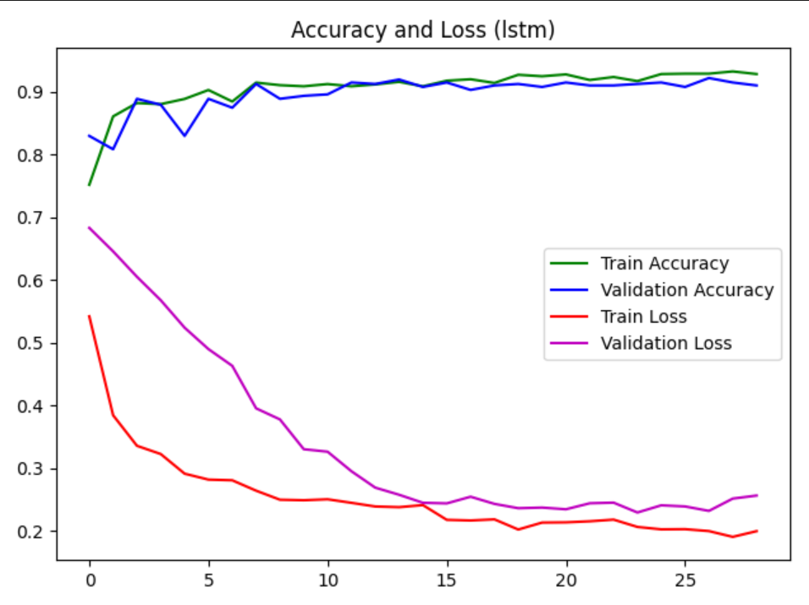
Figure 10: LSTM Model Result analysis of phishing Link Detection System
The LSTM model demonstrated consistent improvement in both training and validation accuracy, reaching values above 90%. Training accuracy stabilized slightly higher than validation accuracy, indicating strong learning without severe overfitting. The loss curves showed a steady decline, with training loss reducing from approximately 0.54 to below 0.20, and validation loss decreasing from around 0.68 to approximately 0.24. The convergence of both accuracy and loss curves suggests that Early Stopping successfully prevented overfitting and enabled the model to generalize effectively. Overall, the LSTM model achieved high classification performance, maintaining stable validation accuracy across epochs.

4.3.2 Bidirectional LSTM Result Analysis

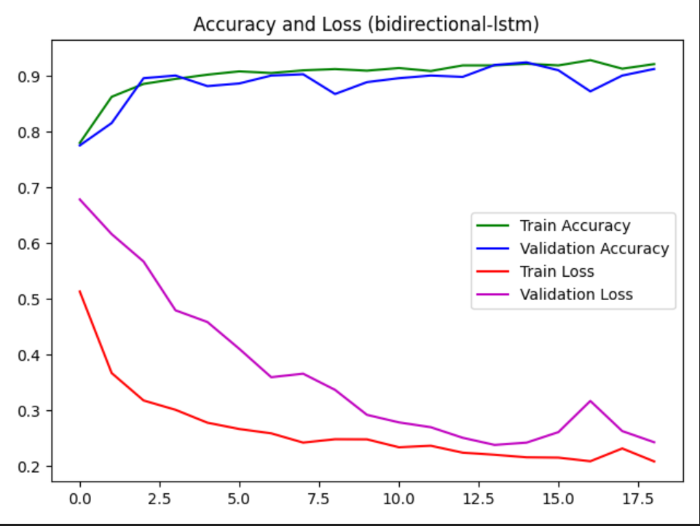
Figure 11: Bi LSTM Model Result analysis of phishing Link Detection System
The Bidirectional LSTM model exhibited high performance with both training and validation accuracy consistently above 90%. Training accuracy reached approximately 93%, while validation accuracy closely followed at around 91–92%, demonstrating stable learning and minimal overfitting. Training loss declined steadily from about 0.52 to nearly 0.20, while validation loss decreased from approximately 0.68 to 0.25, with minor fluctuations in later epochs. The close alignment of accuracy curves and the parallel decline of loss values indicate effective model generalization. Early Stopping contributed to halting training at an optimal stage, preventing unnecessary overfitting and ensuring stable validation performance.

4.3.3 CNN-LSTM Model Result Analysis

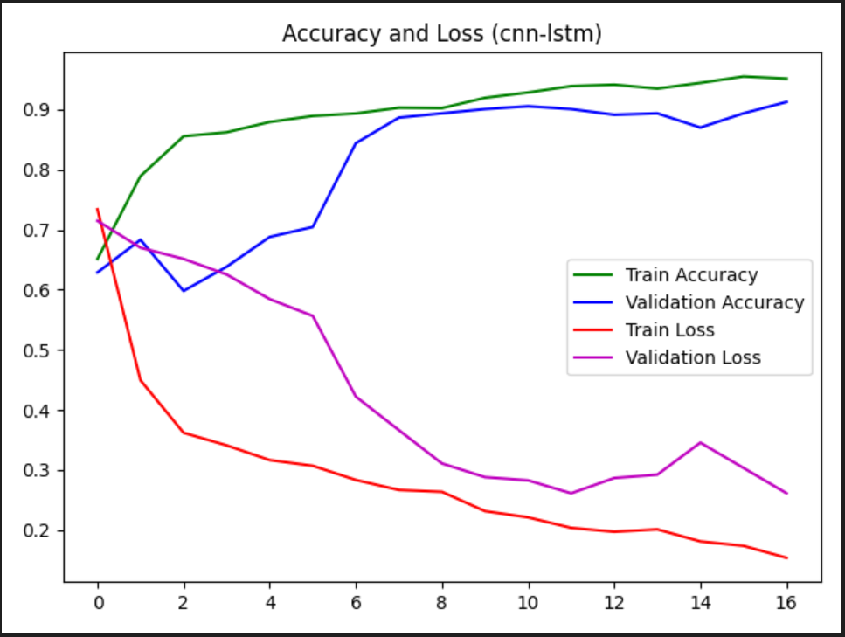
Figure 12: CNN-LSTM Model Result analysis of phishing Link Detection System
The CNN-LSTM model achieved strong performance with both training and validation accuracy surpassing 90% after several epochs. Training accuracy showed a steady upward trend, reaching approximately 95%, while validation accuracy stabilized slightly lower around 91–92%. Training loss decreased consistently from about 0.74 to below 0.16, and validation loss declined from around 0.72 to approximately 0.26, with occasional fluctuations. The overall trend of the curves indicates effective learning and good generalization. Despite minor variations in validation accuracy and loss, the model maintained stable performance, suggesting that Early Stopping successfully reduced the risk of overfitting.

Among the three evaluated models, the Bidirectional LSTM achieved the most consistent and balanced performance. Both training and validation accuracy remained closely aligned above 90%, indicating strong learning with minimal overfitting. The validation loss curve was stable and demonstrated a steady decline, confirming effective generalization on unseen data. While the CNN-LSTM and standard LSTM models also reached high accuracy levels, their validation curves exhibited slightly larger fluctuations compared to the Bidirectional LSTM. Based on accuracy stability and loss convergence, the Bidirectional LSTM can be considered the most effective model for phishing link detection in this study.

CHAPTER 5: CONCLUSION AND EXPECTED/LEARNING OUTCOME

5.1 Conclusion
This project successfully developed a Phishing Link Detection System using an LSTM-based model to identify and block phishing URLs in real time, enhancing online security by preventing identity theft and financial losses. Built on a FastAPI backend with a user-friendly interface, the system ensures accuracy and usability through a rigorous V-model methodology. While limitations like false positives and challenges with sophisticated phishing techniques exist, continuous updates and feedback integration address these gaps, providing a robust foundation for future improvements against evolving cyber threats.

Future Recommendation
The phishing link detection system can have the following recommendations that can be implemented in future:
1. Feedback Loop & Active Learning
- Implement user feedback for false positive/negative reporting
- Create continuous model retraining pipeline with new validated data
- Browser Extension Development
- Real-time URL checking before page loads via browser’s extension
- Visual warnings through toolbar icons
- Email Phishing Detection
- Adapt model for email analysis (headers, content, links)
- Add support for attachment scanning
- Additional Enhancements
- Multilingual phishing detection support
- Mobile app for URL scanning

REFERENCES
easydmarc.(n.d.).Retrieved August 10, 2024, from https://easydmarc.com/tools/phishing
url
Hochreiter, S. a. (1997). Long short-term memory. Neural computation, 9(1997), 173
1780.
Rou, R. &. (2015). ScienceDirect. PhishShield: A Desktop Application to Detect Phishing
https://www.sciencedirect.com/science/article/pii/S1877050915013411
Sherstinsky, A. (2020). Fundamentals of Recurrent Neural Network (RNN) and Long-
Short
Term Memory (LSTM) Network. Physica D: Nonlinear Phenomena, 404, 43 pages.
Prasad, A. & Chandra, S. (2024). PhiUSIIL Phishing URL (Website) [Dataset]. UCI Machine Learning Repository. https://doi.org/10.1016/j.cose.2023.103545.

APPENDIX

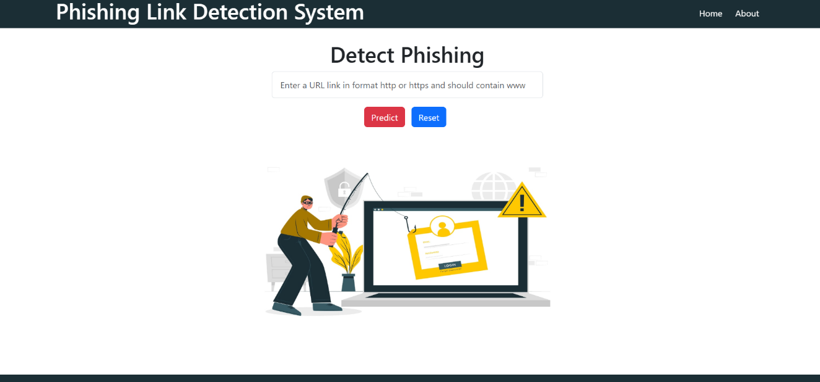
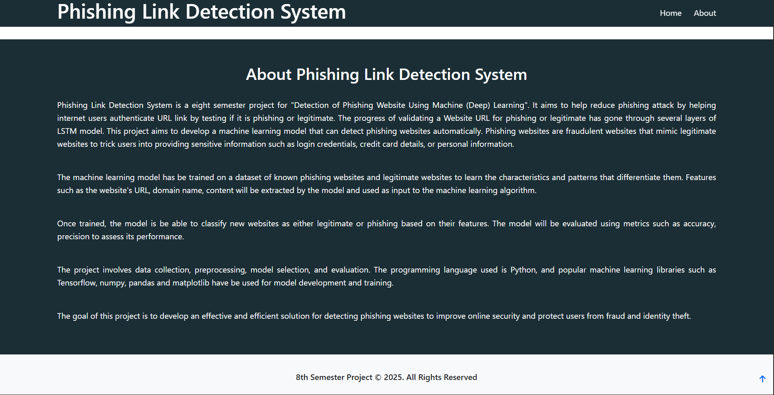
Figure 13: Landing Page of Phishing Link Detection System
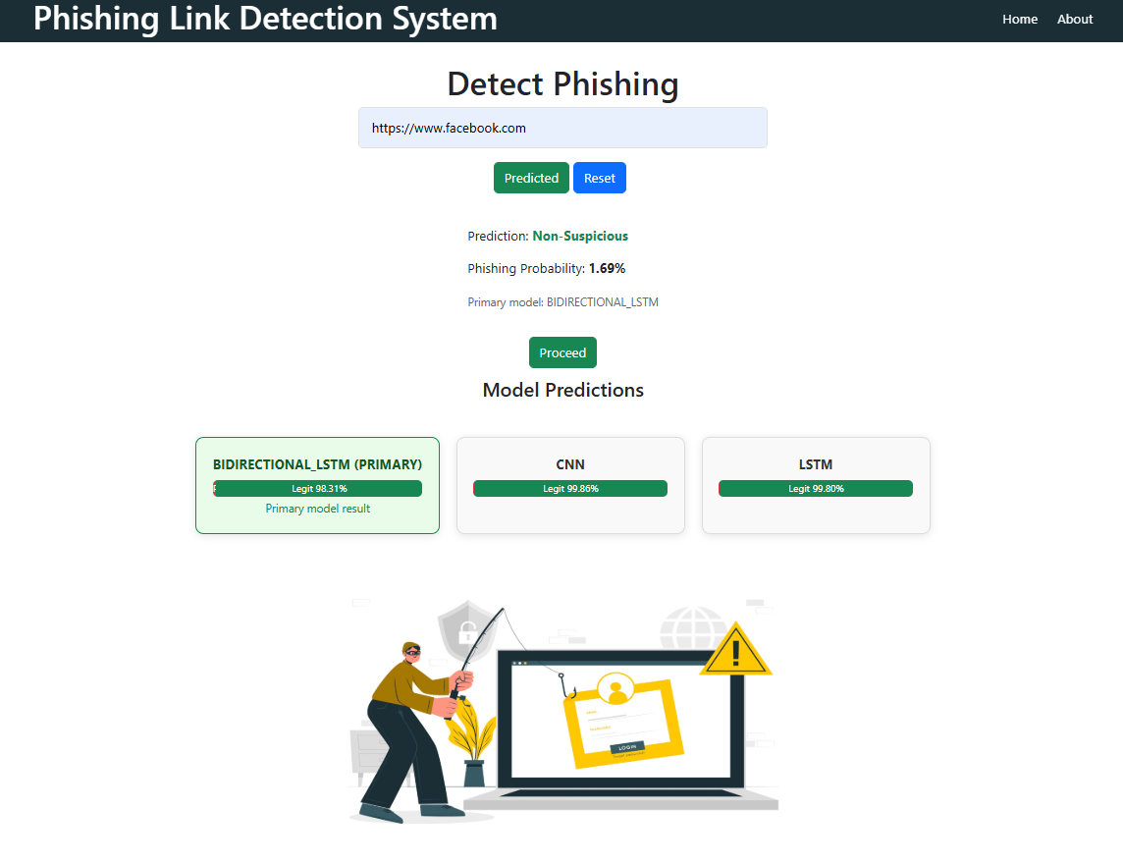
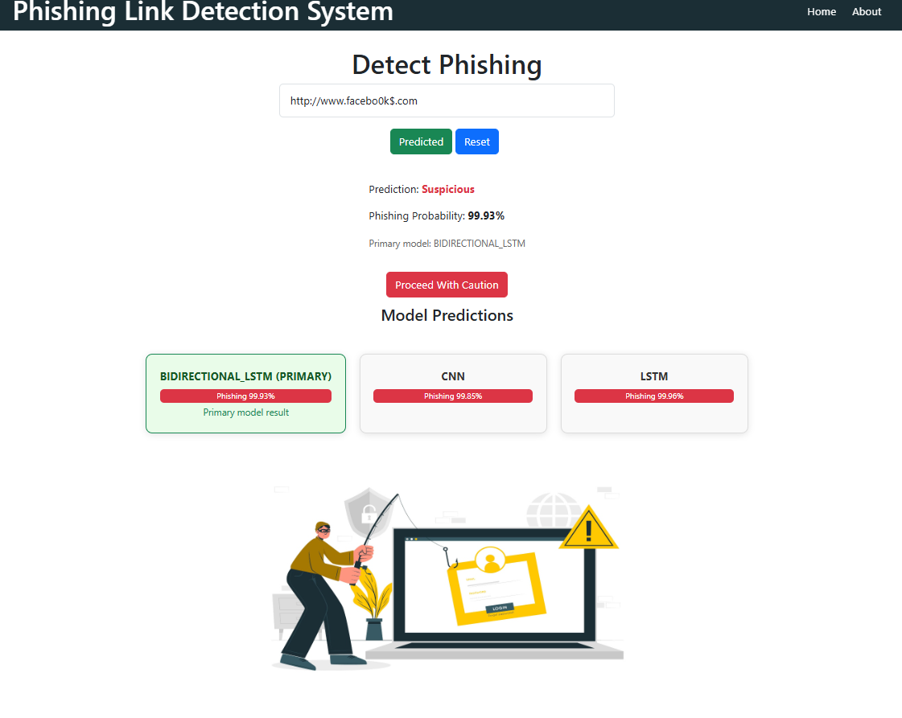
Figure 14: Detection of Phishing and Non-phishing on
Phishing Link Detection System

